Icon Library

🔹 Definition
# Source: ScreenShots Source: Provided by: [Persons Table -> ID Column: 1, Name_En Column: Motasem Essam] -> Tool: [Lightshot Program] -> From [Site: https://icon-library.com/] on [11/15/2025]
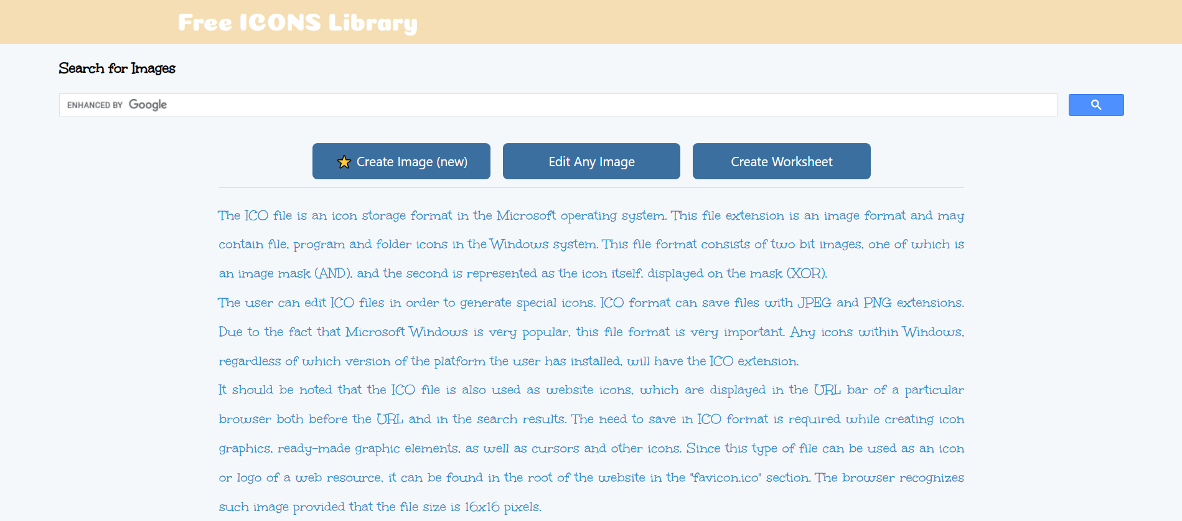
# Source: AI Source: Provided by: [Data Path: Persons Table -> ID Column: 1, Name_En Column: Motasem Essam] -> From: [ChatGPT] on [11/15/2025]
Icon Library — https://icon-library.com/ — is a website providing free and royalty-free icons for personal and commercial use. Here’s a detailed breakdown:
- Icon Library is an online repository of icons in various styles and formats (PNG, SVG, ICO).
- Users can search, browse, and download icons for use in websites, apps, presentations, or graphic design projects.
- Categories include social media, UI elements, objects, symbols, business, technology, and more.
- Offers icons for personal, educational, and commercial projects, often royalty-free.

🎯 Purpose
# Source: AI Source: Provided by: [Data Path: Persons Table -> ID Column: 1, Name_En Column: Motasem Essam] -> From: [ChatGPT] on [11/15/2025]
- To provide designers, developers, and content creators with easy access to free icons.
- Simplifies the process of finding consistent visual elements for digital or print projects.

🛡️ Safety & Legality
# Source: AI Source: Provided by: [Data Path: Persons Table -> ID Column: 1, Name_En Column: Motasem Essam] -> From: [ChatGPT] on [11/15/2025]
- The site is legal and safe to use.
- Most icons are royalty-free, but users should check the specific license for each icon before commercial use.
- Does not host malware or illegal content.

📌 Summary
# Source: AI Source: Provided by: [Data Path: Persons Table -> ID Column: 1, Name_En Column: Motasem Essam] -> From: [ChatGPT] on [11/15/2025]
Icon Library is a trusted online platform offering free and royalty-free icons for design and development projects. It is safe, legal, and easy to use for personal, educational, or commercial purposes.

